A COMPREHENSIVE ANALYSIS OF FINANCIAL PERFORMANCE :INSIGHTS FROM A LEADING BANKS

1.INTRODUCTION

1.1 Overview

We take the project ‘’ A COMPREHENSIVE ANALYSIS OF FINANCIAL PERFORMANCE :INSIGHTS FROM A LEADING BANKS’’

We understand that if we finish this project it will be helpful for the bankers to improve and develop overall financial health of the bank and bring new innovations and ideas to the market for the people’s need.

1.2 Purpose

Financial analysis is the process of evaluating businesses,projects ,budgets and other finance related transactions to determine their performance and suitability.

2.PROBLEM DEFENITION AND DESIGN THINKING

2.1 Empathy map

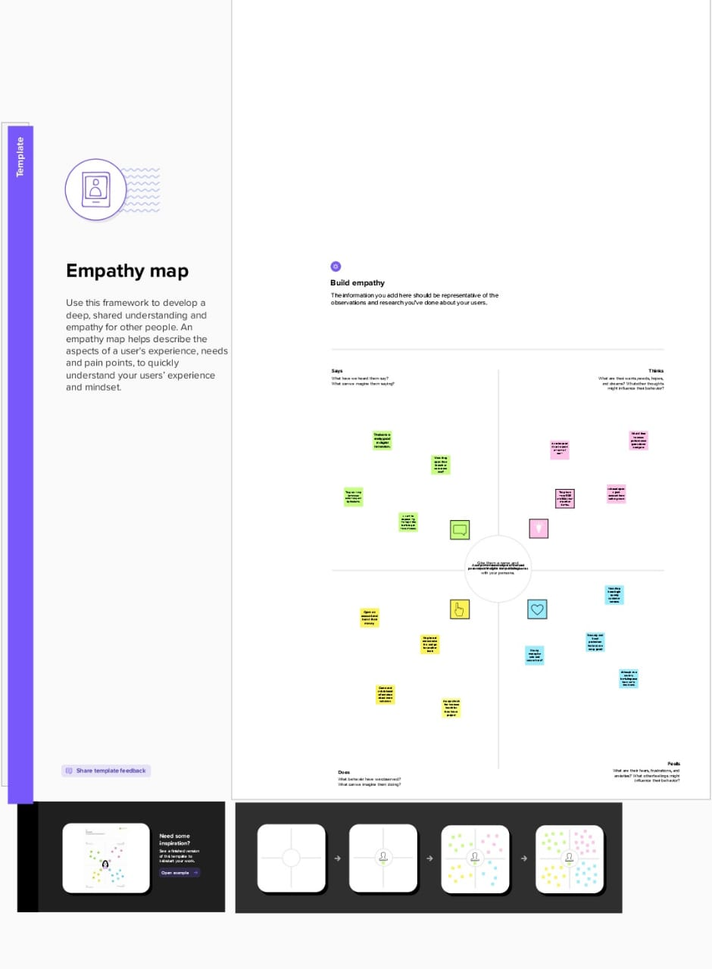

2.2 Ideation and brain storming map

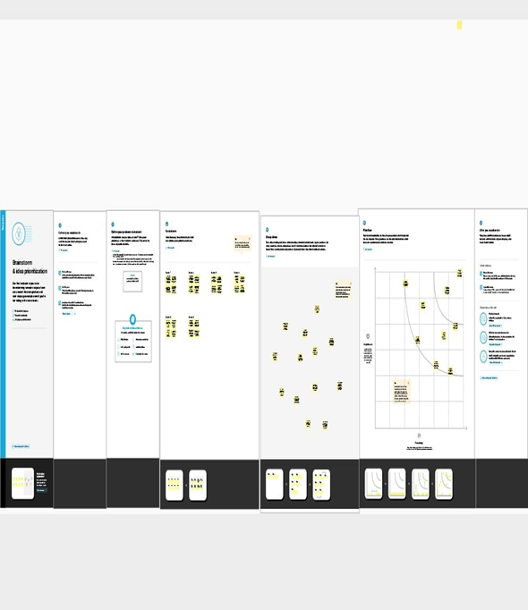

3.RESULT

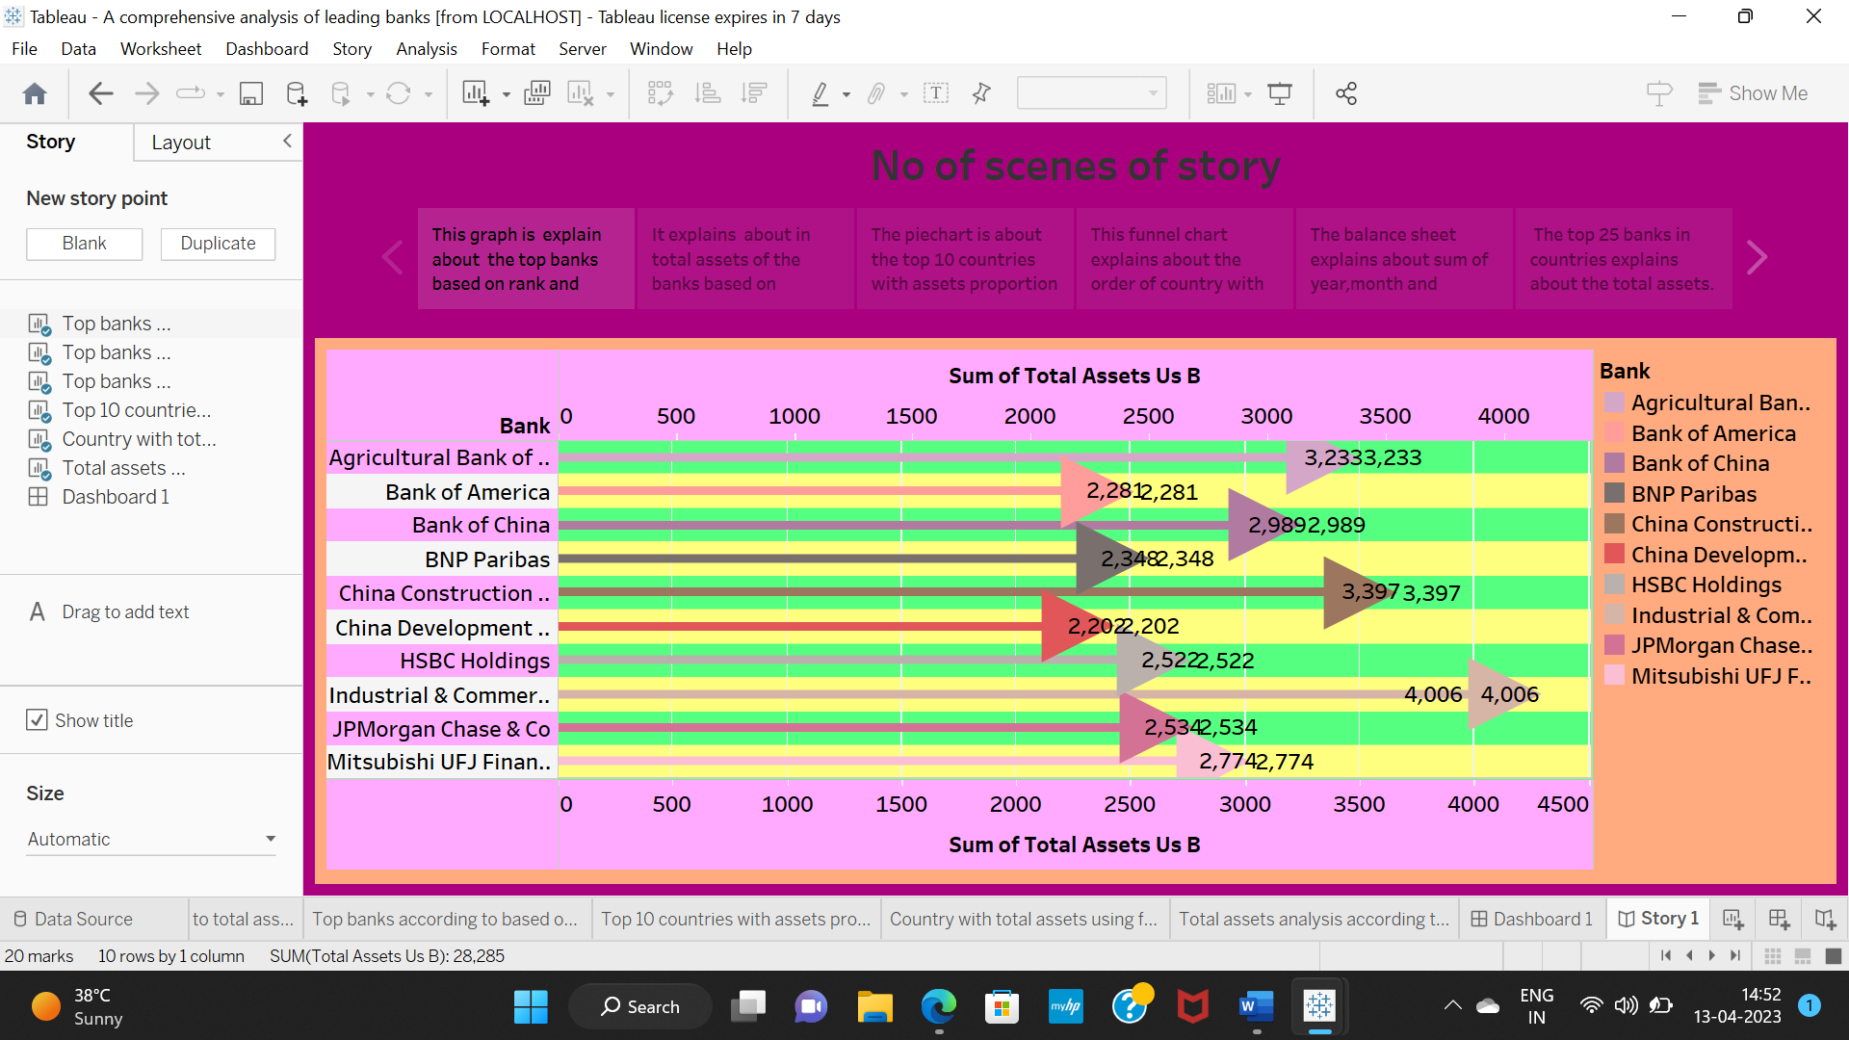

4.ADVANTAGES & DISADVANTAGES

Advantages

Reduction of financial risks.

Increased opportunities.

Increased credibility.

Small fee or commission.

Less documentation.

Disadvantages

Strict assessment by banks.

Requirement of collateral.

Chances of bank going bankrupt.

Risk of public debt.

5.APPLICATIONS

There are four main areas of finance

Banks

Institutions

Public accounting

Corporate

Working capital.

6.CONCLUSION

In conclusion banking holds a crucial role in our day to-day life . we must adhere to the banking systems as responsible citizens.

It provides a base to market and the companies.

7.FUTURE SCOPE

The various position in a bank are stated below typically an individual joining as a probationary officer can hope to become a bank general manager in more or less 14 years.

8.APPENDIX

https://drive.google.com/drive/folders/1dMvB_fWVLu_MQCRPXDcY4RfGgus_7oeR?usp=share_link